1. SPRING-REST-HANDSON

1)Create a Spring Web Project using Maven

Code:

SpringLearnApplication.java:

**package** com.cognizant.spring_learn;

import org.springframework.boot.SpringApplication;

import org.springframework.boot.autoconfigure.SpringBootApplication;

import org.slf4j.Logger;

import org.slf4j.LoggerFactory;

@SpringBootApplication

public **class** SpringLearnApplication {

private static final Logger log = LoggerFactory.getLogger(SpringLearnApplication.class);

public static void main(String[] args) {

SpringApplication.run(SpringLearnApplication.class, args);

log.info(">>> SpringLearnApplication started successfully");

}

}

Output:

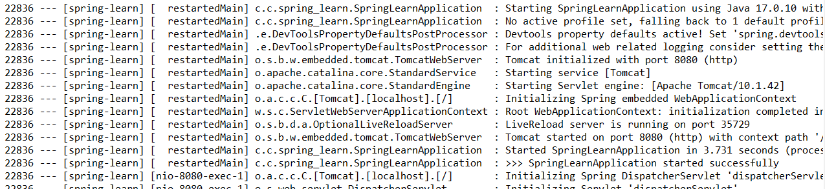

2) Spring Core – Load Country from Spring Configuration XML

Code:

SpringLearnApplication.java:

**package** com.cognizant.spring_learn;

import org.slf4j.Logger;

import org.slf4j.LoggerFactory;

import org.springframework.boot.autoconfigure.SpringBootApplication;

import org.springframework.context.ApplicationContext;

import org.springframework.context.support.ClassPathXmlApplicationContext;

@SpringBootApplication

public **class** SpringLearnApplication {

public static final Logger LOGGER = LoggerFactory.getLogger(SpringLearnApplication.class);

public static void main(String[] args) {

LOGGER.debug("START");

displayCountry();

LOGGER.debug("END");

}

public static void displayCountry() {

ApplicationContext context = new ClassPathXmlApplicationContext("country.xml");

Country country = context.getBean("country", Country.class);

LOGGER.debug("Country : {}", country.toString());

}

}

County.java :

**package** com.cognizant.spring_learn;

public **class** Country {

private String code;

private String name;

public Country() {

}

public **String** getCode() {

return code;

}

public void setCode(**String** code) {

this.code = code;

}

public **String** getName() {

return name;

}

public void setName(**String** name) {

this.name = name;

}

@Override

public **String** toString() {

return "Country [code=" + code + ", name=" + name + "]";

}

}

country.xml:

<?xml version="1.0" encoding="UTF-8"?>

<beans xmlns="http://www.springframework.org/schema/beans"

xmlns:xsi="http://www.w3.org/2001/XMLSchema-instance"

xsi:schemaLocation="http://www.springframework.org/schema/beans

http://www.springframework.org/schema/beans/spring-beans-3.1.xsd">

<bean id="country" **class**="com.cognizant.spring_learn.Country">

<**property** name="code" value="**IN**"/>

<property name="name" value="India"/>

</bean>

</beans>

Output:

